1. **Problem Statement**

Automatic License Plate Recognition (ALPR) is emerging technology that eliminates human involvement and identifies license plates automatically. It helps to track vehicles, enforce rules related to traffic violations. Various machine learning algorithms have been tested for License plate recognition as Artificial Neural Network (ANN), Optical Character Recognition (OCR), K-Nearest-Neighbour (KNN). Our aim is to select best algorithm out of the above.

1. **Problem Analysis**

There are different problems related to License plate recognition. First is non-standardization of license plate. There are different license plates in different countries and that may of varying size. Second, video recorder may be of lower resolution that required which results in difficulty in reading license plate. Third, environmental factors as rain or snow may hamper reading license plates. We will try to cover every aspect in the specification section.

1. **Specification**

Basic steps involved for detecting ALPR are

1. Image or Photo acquisition
2. License plate extraction
3. License plate segmentation
4. Character String recognition

OpenCV which is an open source computer vision library. It contained 2500 optimized algorithms including those of machine learning algorithms. These algorithms include face detection, 3D object modeling, specific object detection, combining images to create high resolution pictures etc. We will be using OpenCV to implement KNN algorithm by taking value of K as 1. Training of KNN is done separately and grouping and classifier images are stored in response_images.txt and classify_images.txt. Recognition of license plate character string is done using K-Nearest Neighbour algorithm.

KNN Algorithm is simple and easy to implement. In our project, we are not focussing on speed (quantity) but on quality of detection of license plate. Hence, we are proceeding with KNN algorithm. An implementation of ALPR with KNN is given in [I] and ALPR with OpenCV and OCR in [II] which are referenced. An architecture of ALPR with KNN is shown in fig 1.

*Fig 1 – Architecture of License Plate using Machine Learning Algorithm*

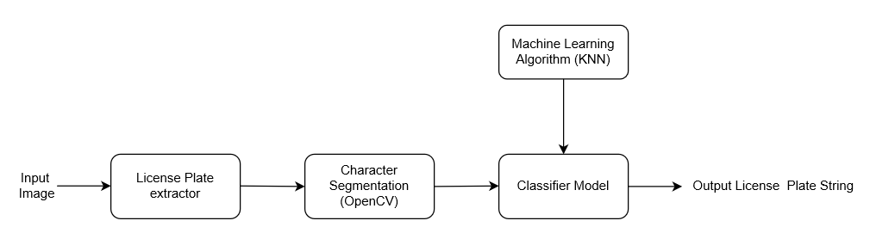

1. **Design**

Pseudo is defined below:

1. Load and Train KNN.
2. Take value ok K=1.
3. **Input** - Read the original image (png) as kept in directory.
4. Preprocess the image using cv2 functionality of getStructuringElement and morphologyEx with the addition of tophat and subtracting blackhat to output threshold image.
5. From Threshold image, get contours.
6. For each contour, find list of lists of matching or comparable characters and add those for which minimum matching list is greater than 3.
7. Find probable license plates using previously identified starting and ending position of character list.
8. Again, Preprocess the image using cv2 functionality.
9. Find longest list of matching or comparable characters with inner characters removed.
10. Resize the license plate image to extract character string.
11. **Output** - Highlight the edges of license plate in original image and outputting the character string of license plate**.**

*Fig – Flow Chart of License Plate recognition using machine learning*

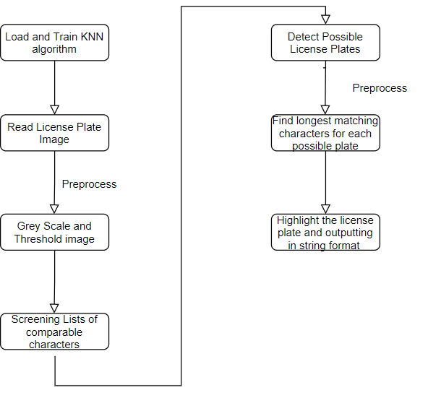

1. **Testing**

|  |  |  |  |  |  |
| --- | --- | --- | --- | --- | --- |
| S.No. | **Test Case** | **Original Image** | **Segmented License plate image** | **Threshold image** | **Result** |
| 1. | Clearly identified License Plate I |  |  |  | Pass |
| 2. | Clearly identified License Plate II |  |  |  | Pass |
| 3. | Clearly identified License Plate III |  |  |  | Fail, out of seven characters, six are identified correctly |
| 4. | Tilted license plate I |  |  |  | Pass |
| 5. | Tilted license plate II |  |  |  | Pass |
| 6. | Tilted license plate III |  |  |  | Fail, out of seven characters, six are identified correctly |
| 7. | Small potion of License plate in image |  |  |  | Pass |
| 8. | Small potion of License plate in image |  |  |  | Pass |
| 9. | License Plate with symbols in between |  |  |  | Pass |
| 10. | License Plate with symbols in between |  |  |  | Fail, out of six characters, five are detected correct |
| 11. | License Plate with symbols in between |  |  |  | Pass |

Out of 11 test cases performed, eight license plates are correctly identified. Remaining three are also correct for most of the characters of license plate with one or two characters wrongly matched with other character.

1. **Impact**

ALPR is beneficial in number of ways. Deployment of ALPR in Intelligent Transportation System (ITS) in the field of Electronic Toll Collection and surveillance activities. It results in improving traffic, reduces labour cost and improving safety and security in the city. While addressing privacy concerns of the people, weather condition and uniformity of license plate, ALPR with KNN and OpenCV can revolutionize our society.

1. **References**
2. Alaidi, Abdul Hadi & Alsaidi, Saif & Yahya, Omar. (2017). Plate Detection and Recognition of Iraqi License Plate Using KNN Algorithm. Journal of College Student Development.
3. Agbemenu, Andrew & Yankey, Jepthah & O., Ernest. (2018). An Automatic Number Plate Recognition System using OpenCV and Tesseract OCR Engine. International Journal of Computer Applications.